**Data Sets:**

1. BitCoin Blockchain: Complete live historical Bitcoin blockchain data (Google BigQuery)

https://www.kaggle.com/bigquery/bitcoin-blockchain/data

* + 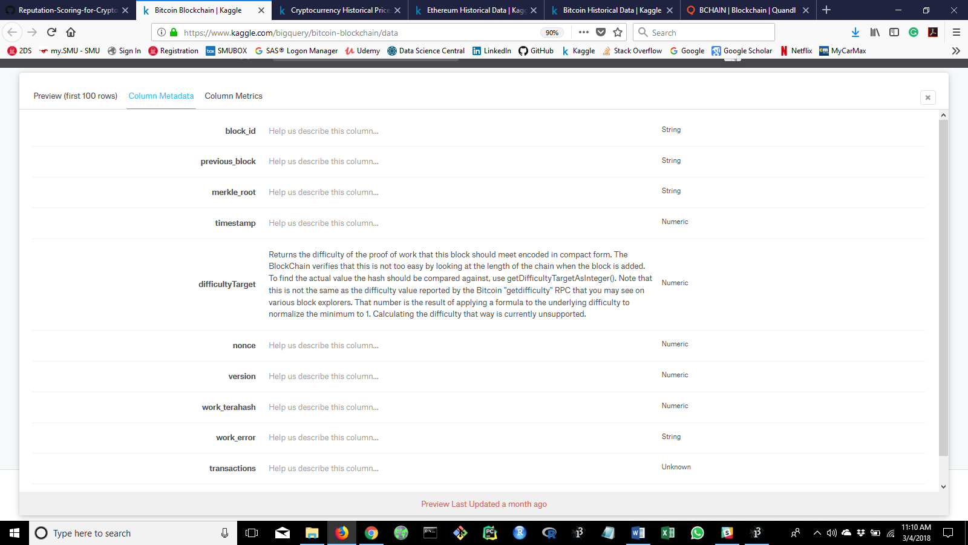Table 1: blocks

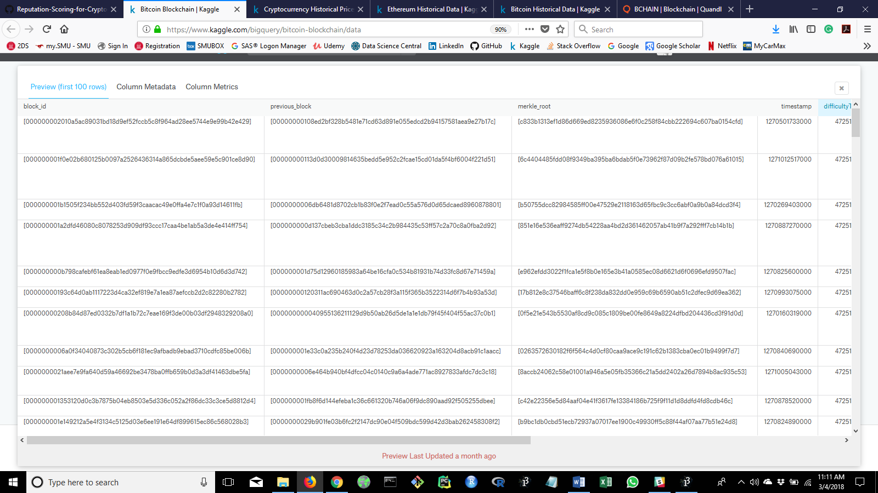

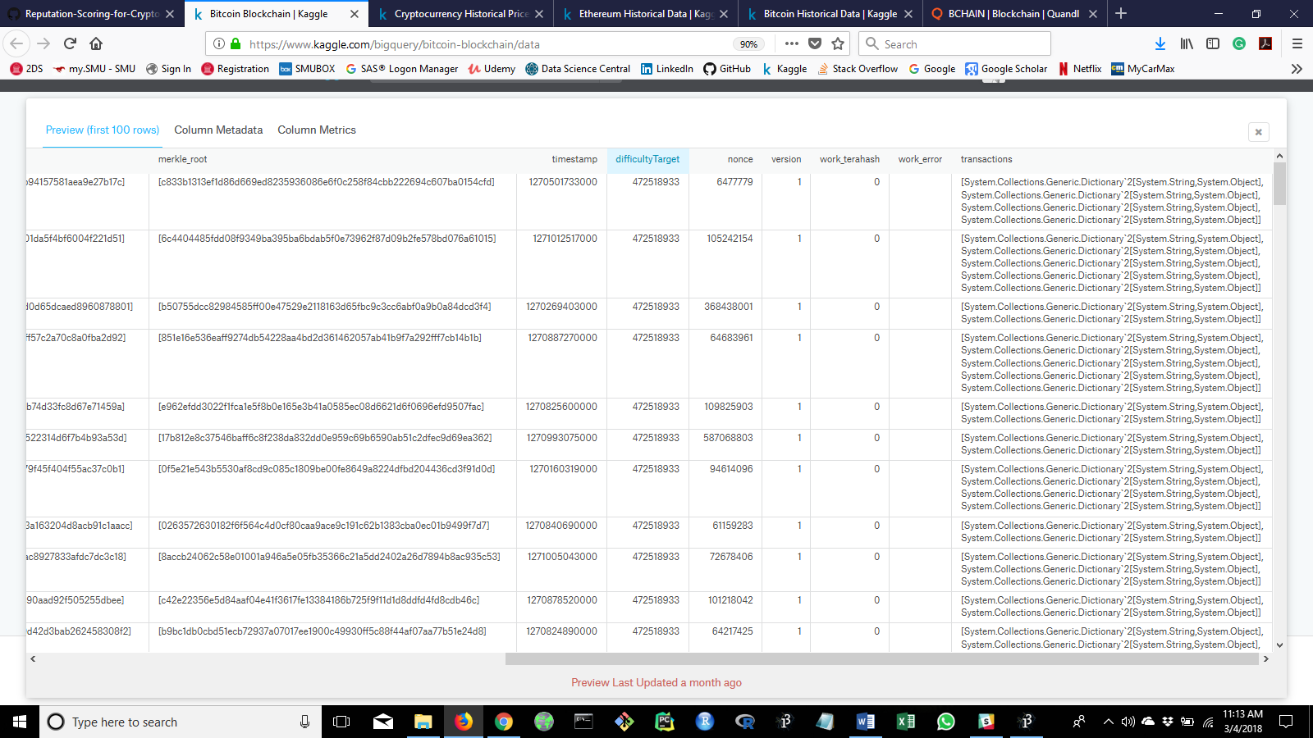

* + 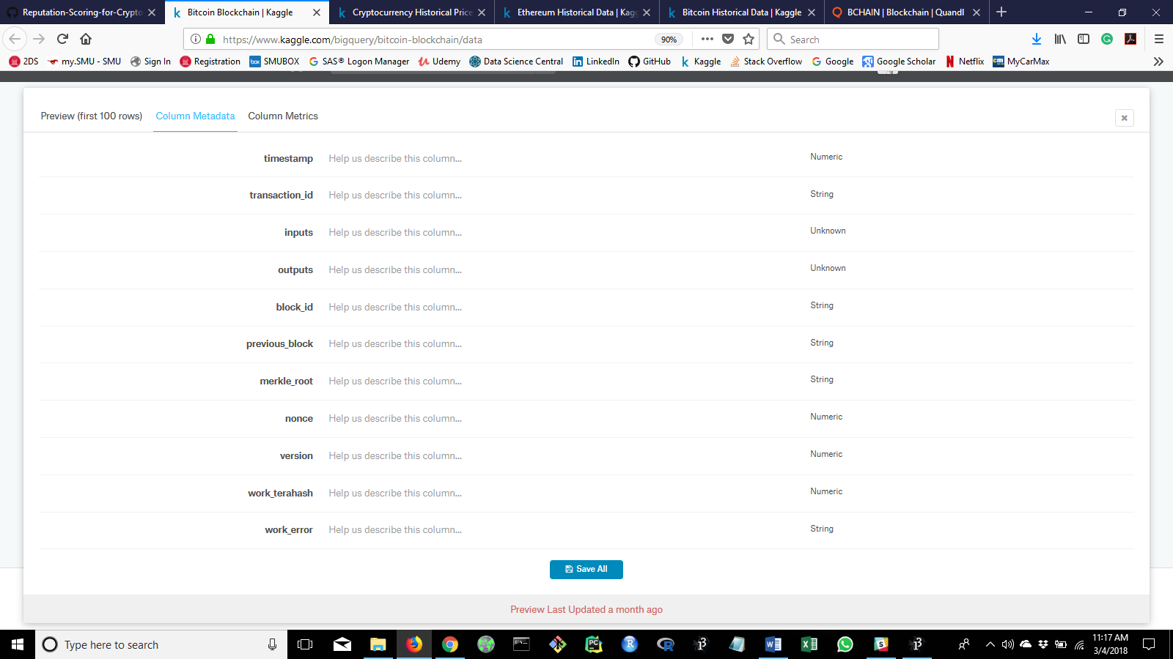Table 2: transactions

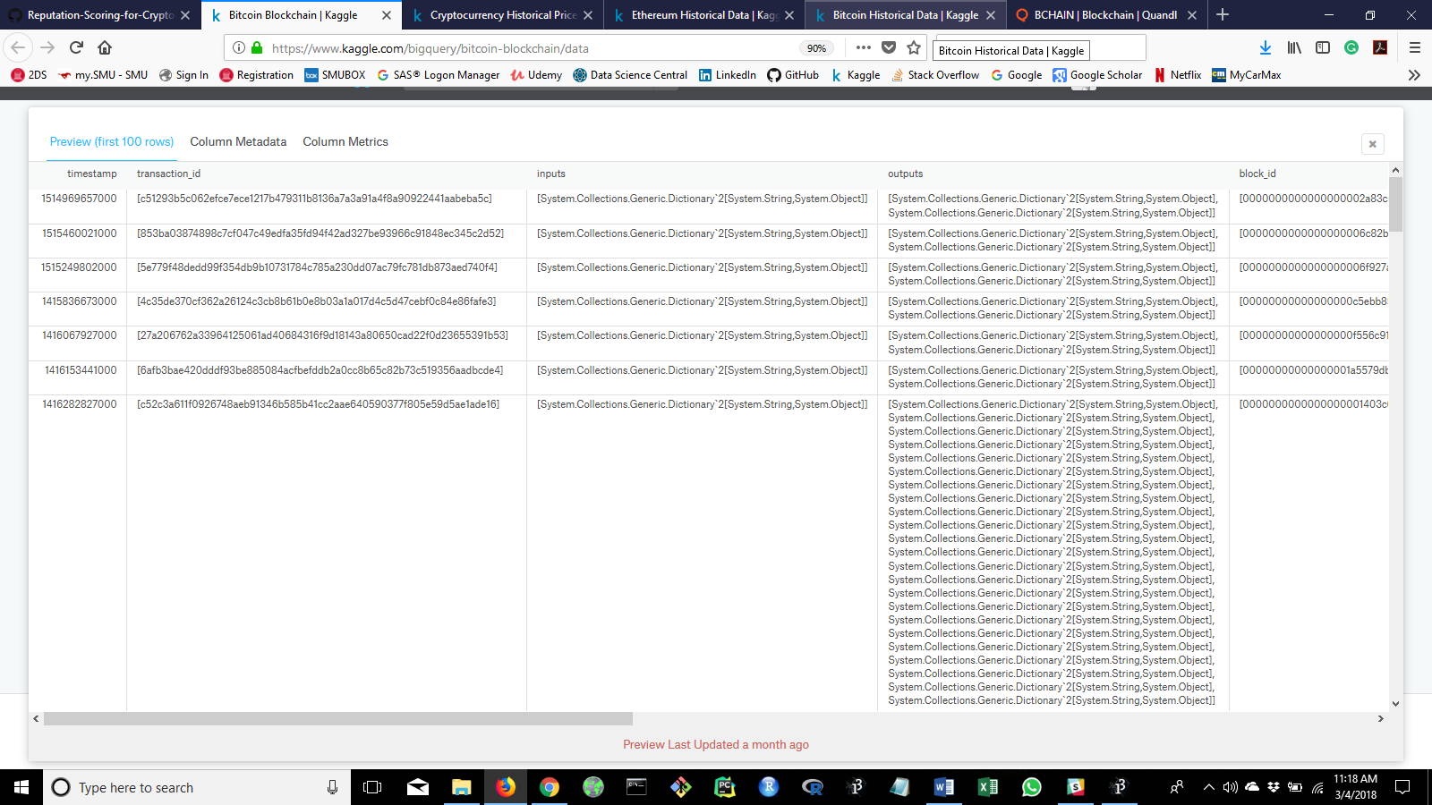

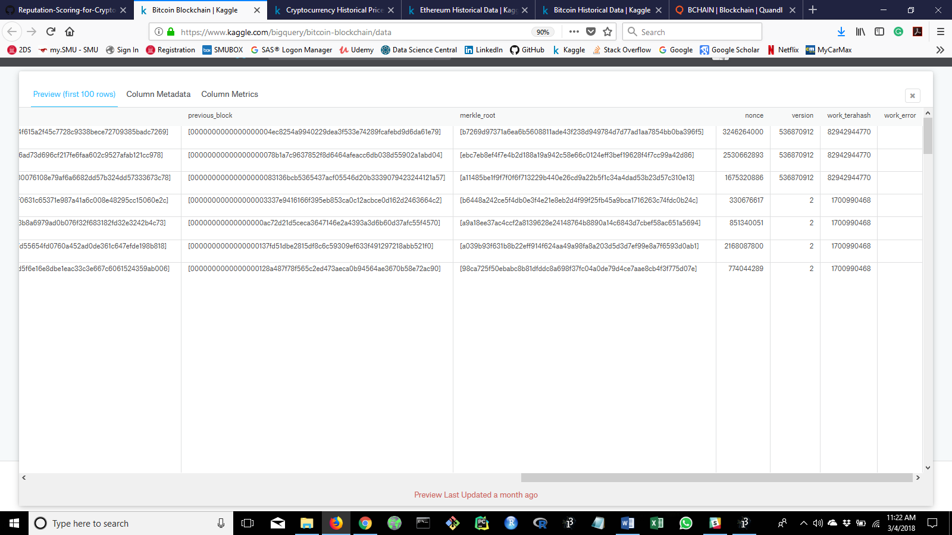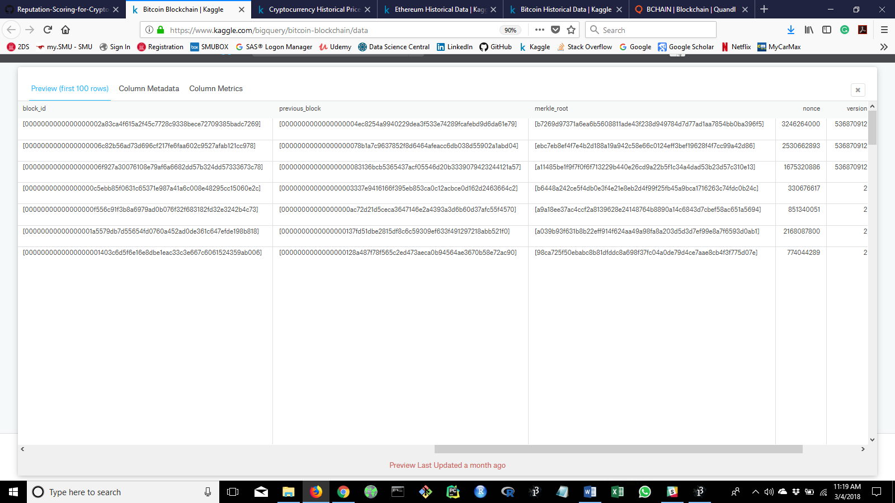

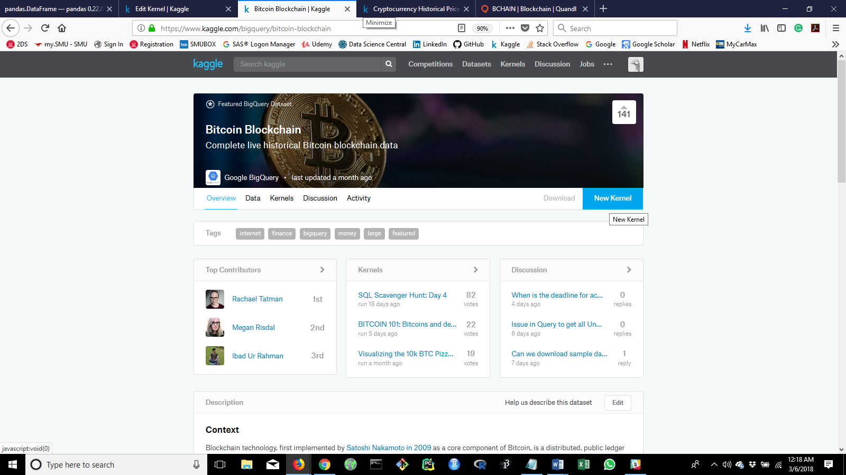

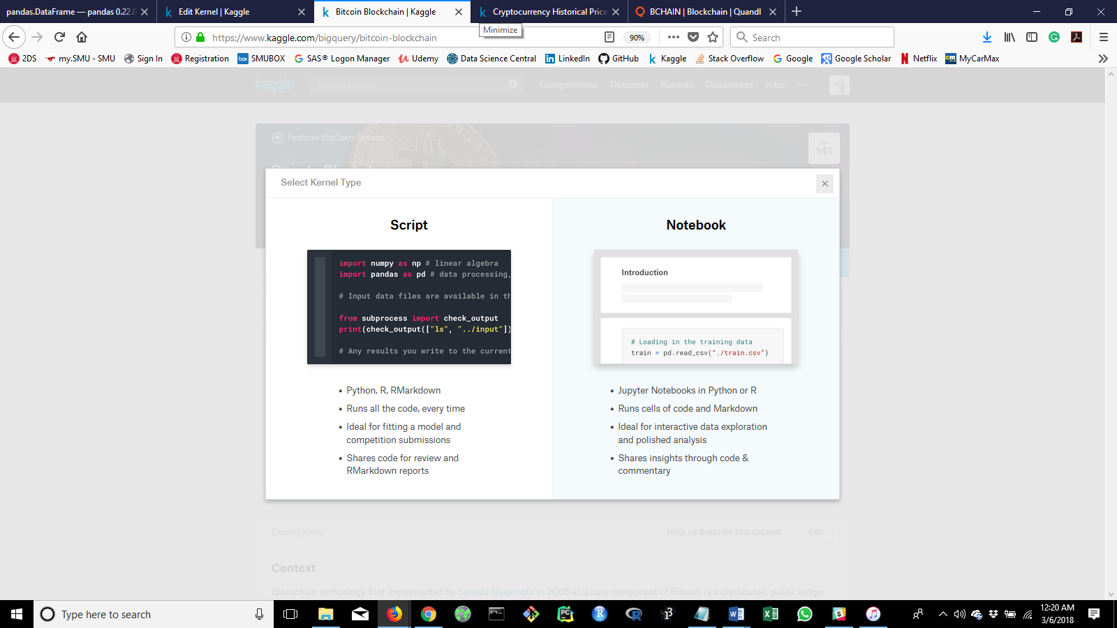

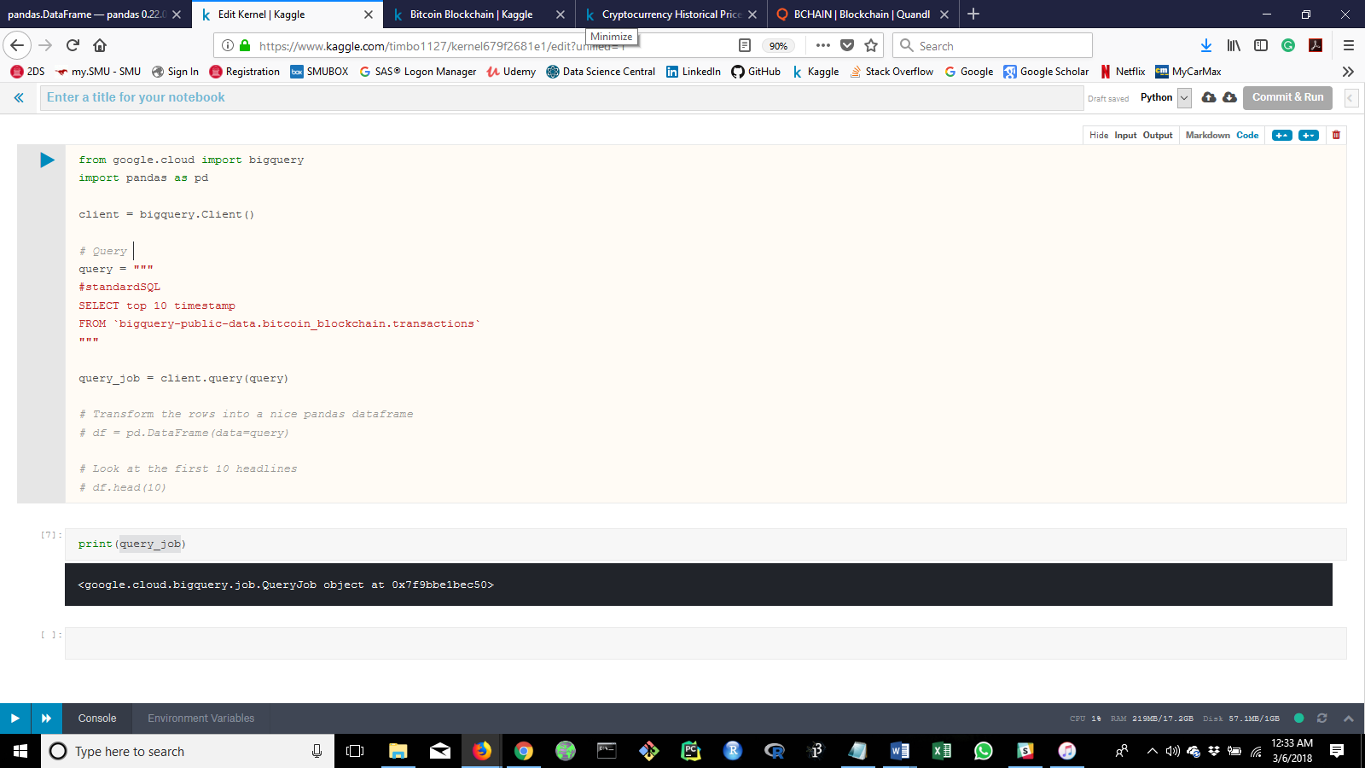

1. Cryptocurrency Historical Prices: Prices of top cryptocurrencies including Bitcoin, Ethereum, Ripple, Bitcoin cash (csv files). There are tables for each coin that are the same as the following tables.

https://www.kaggle.com/sudalairajkumar/cryptocurrencypricehistory/data

* + 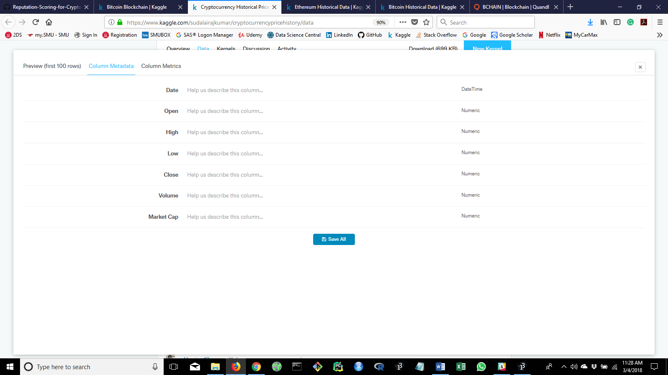Table 1: bitcoin cash price

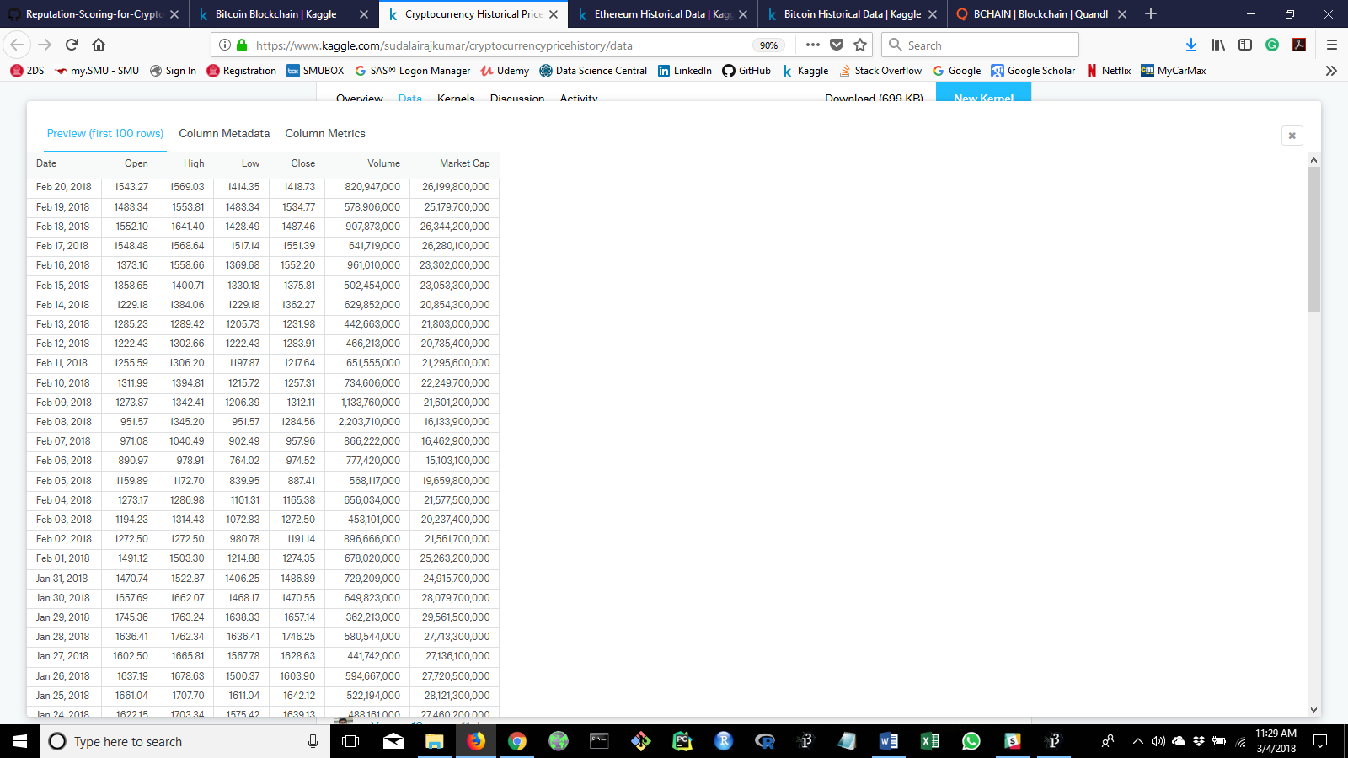

* + 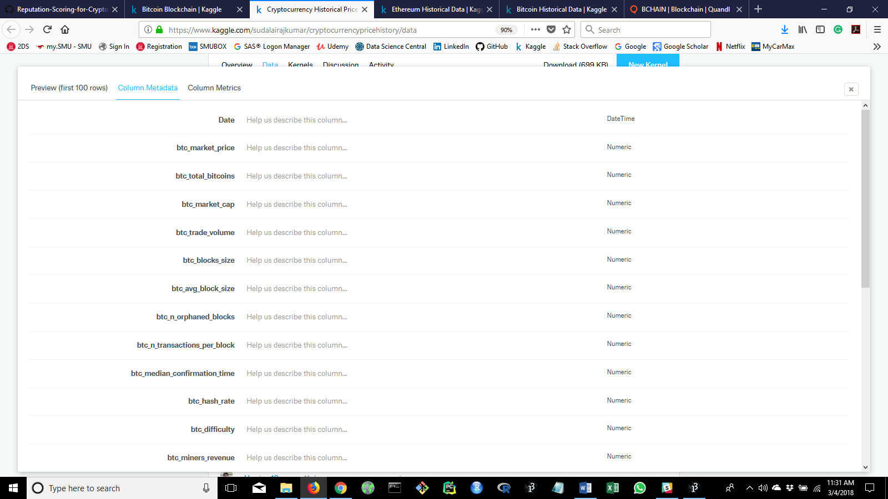Table 2: bitcoin dataset

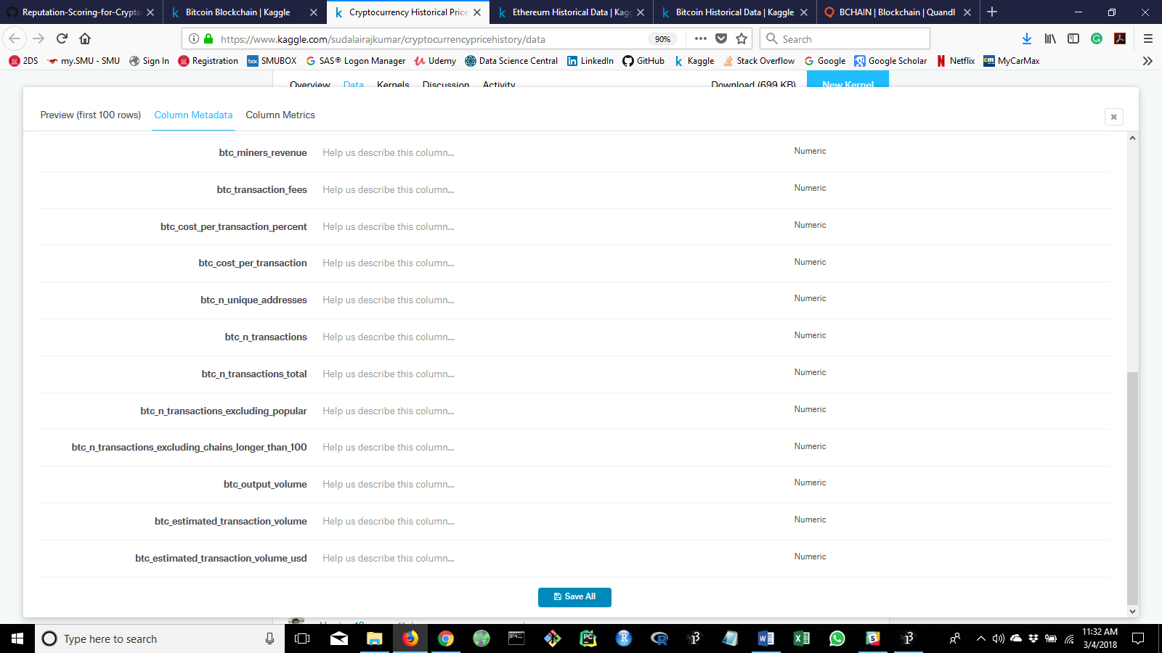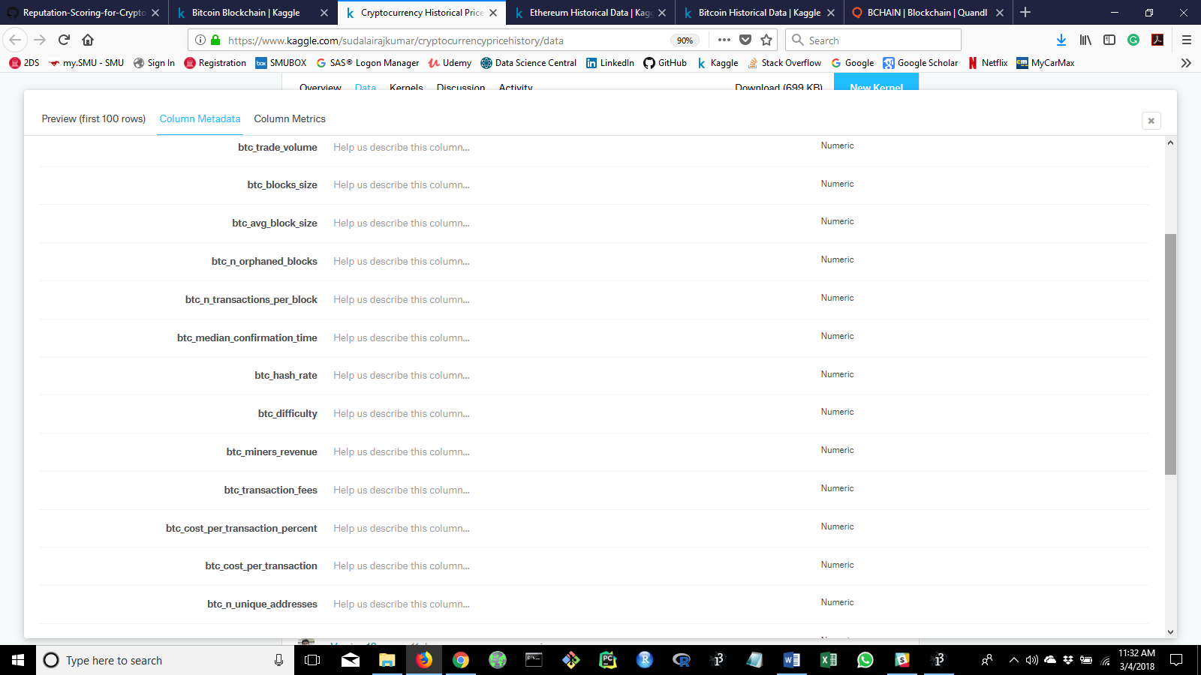

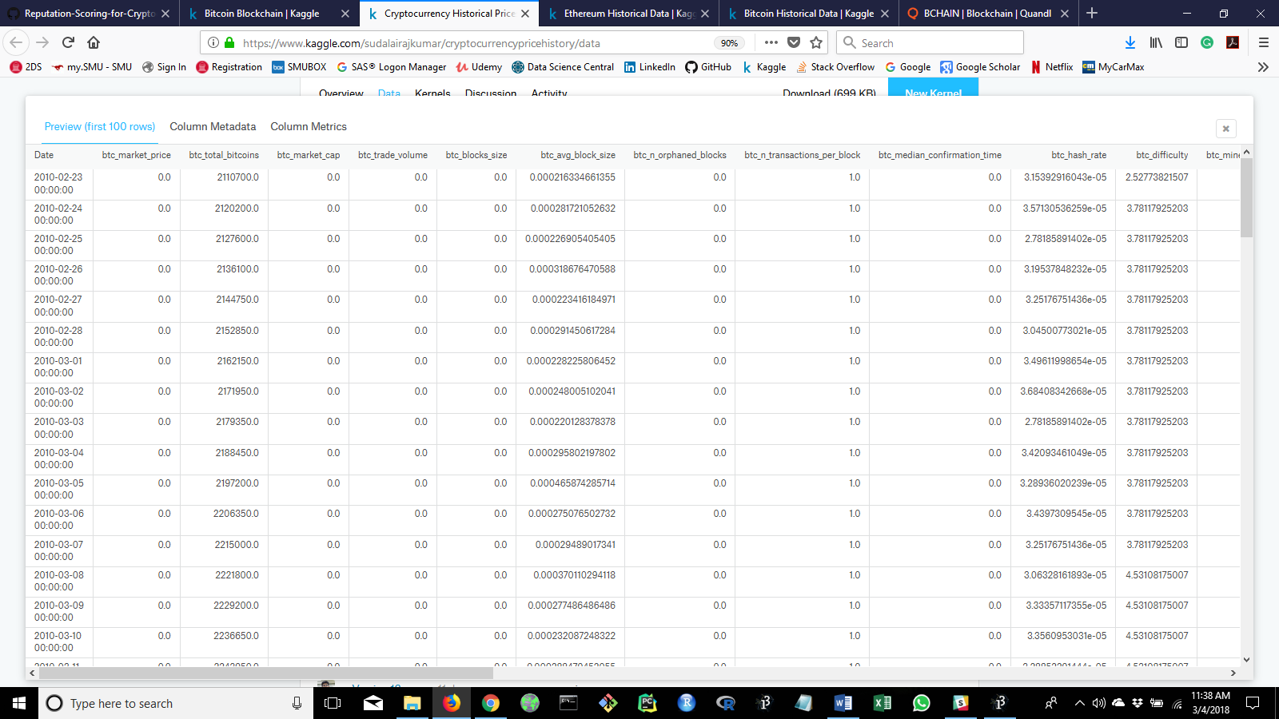

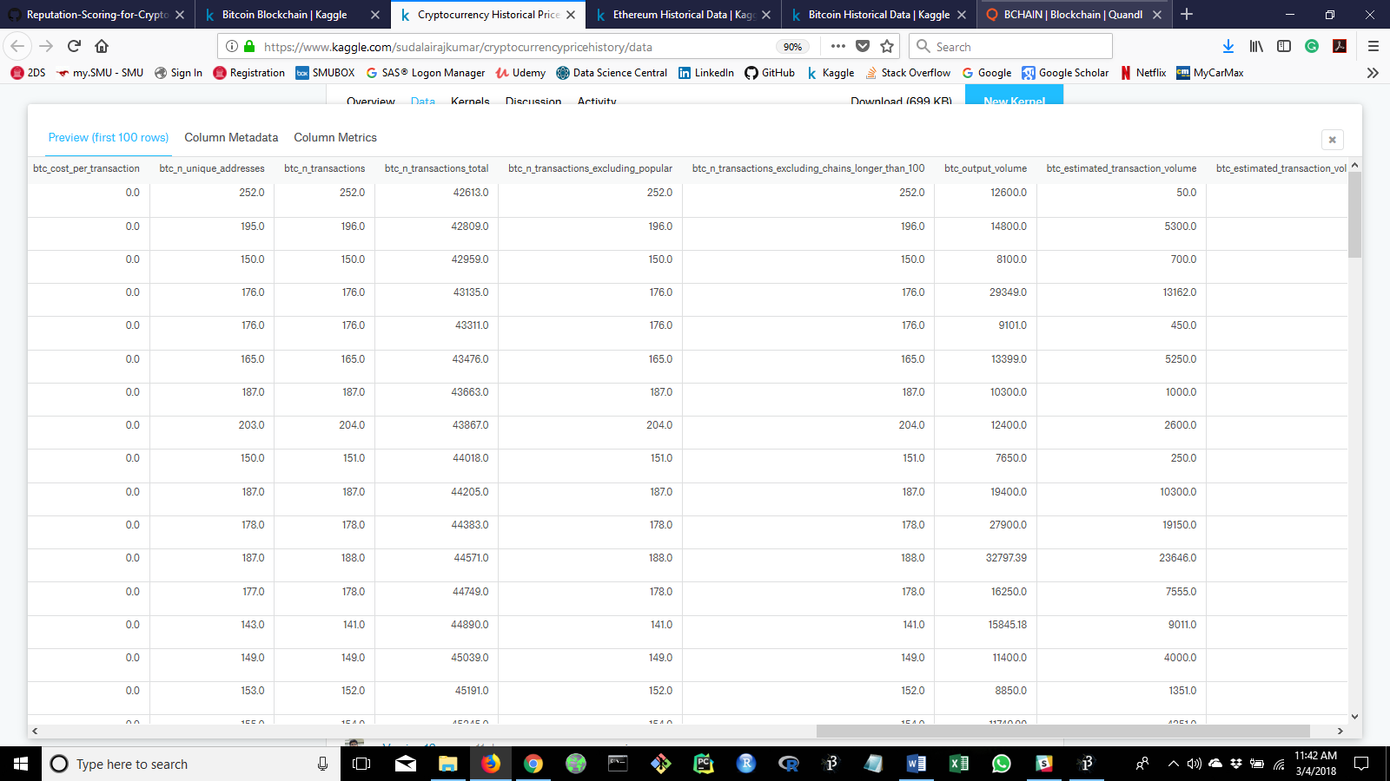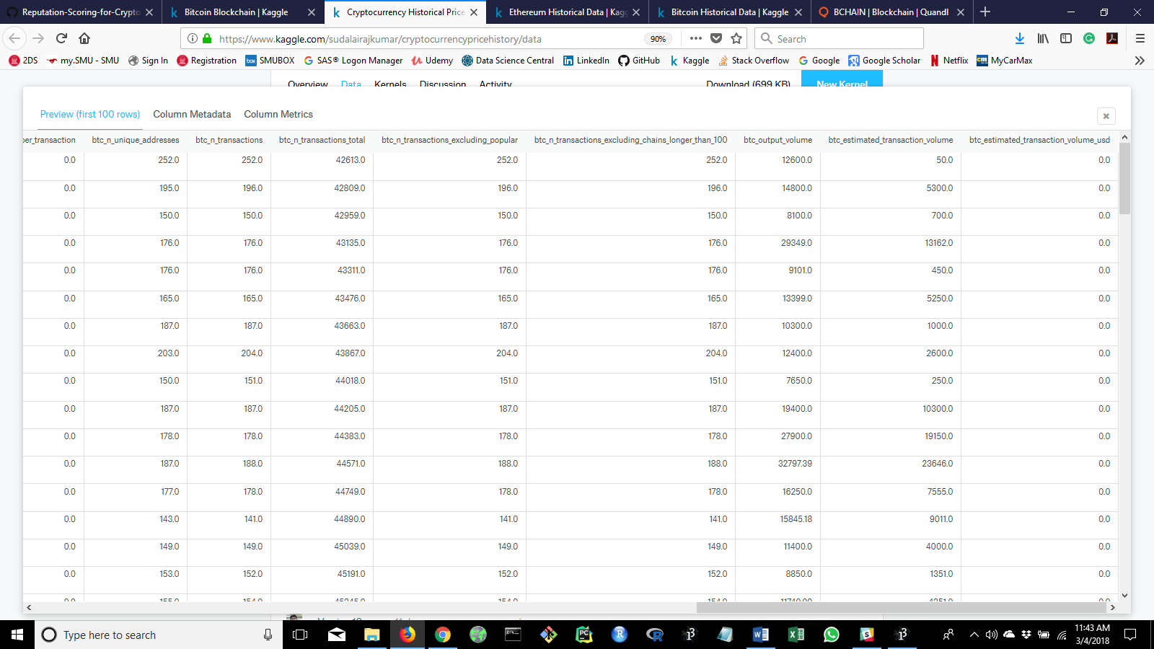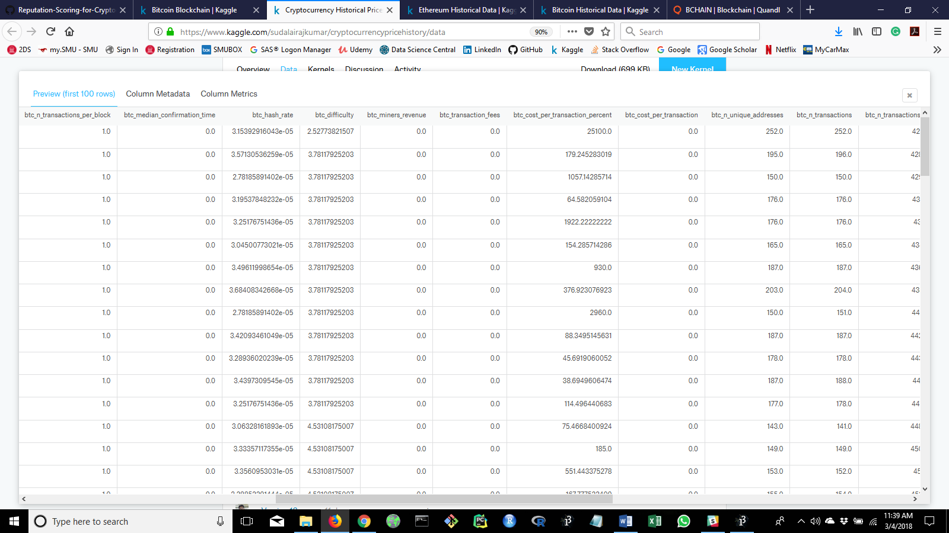

1. Qundl: Need to sign up first!!! Then pick a data set.

https://www.quandl.com/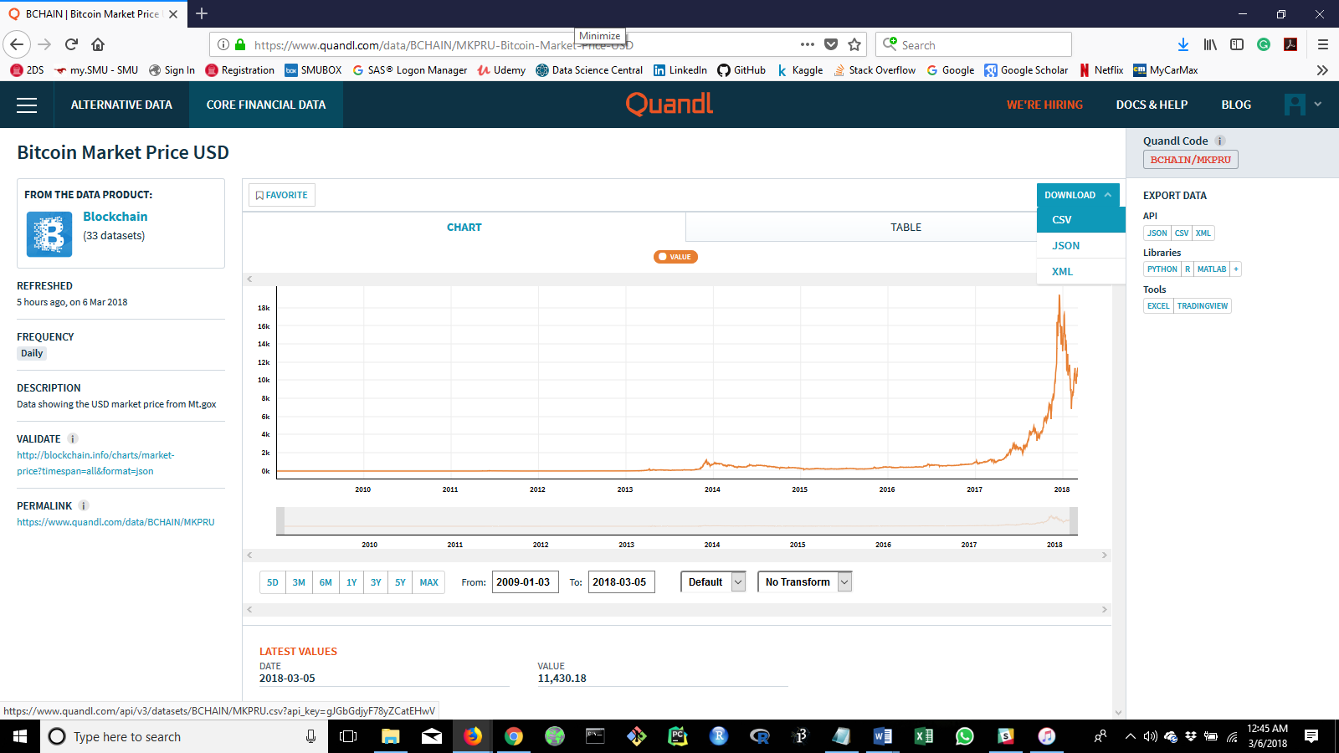

Download the data as a CSV and save the file where you can open it in Jupyter Notebook.

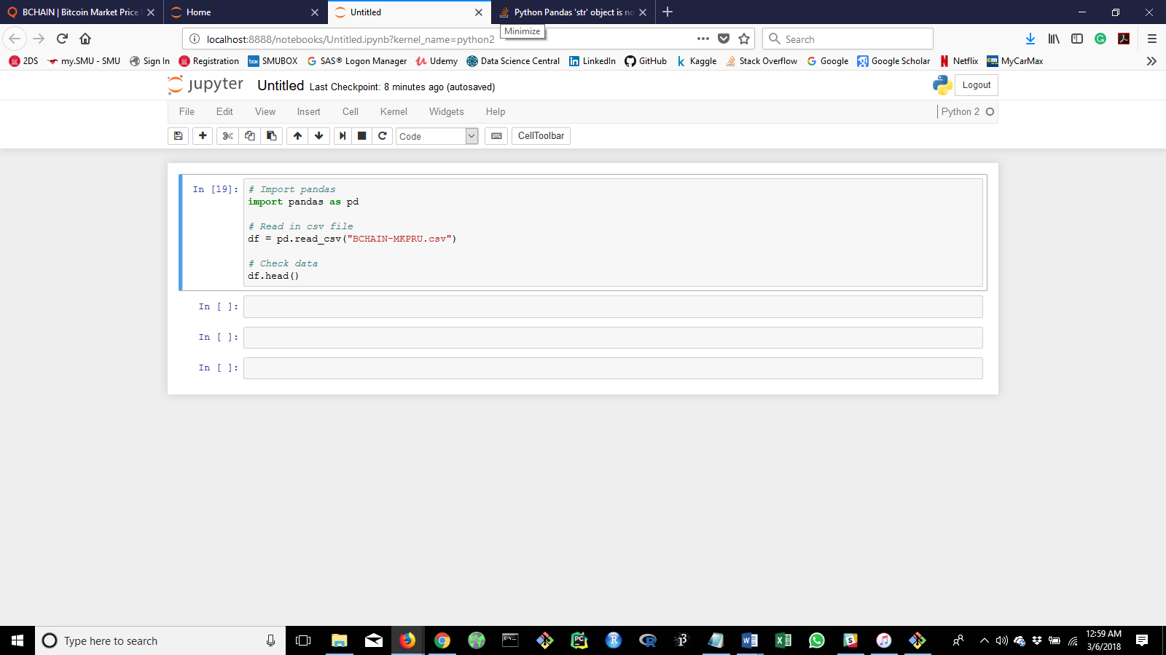Once the csv file is saved, simply read it into python as a pandas data frame. Example,